QuickBooks Final Project_Case Problem 3
General instructions
- Please refer to pages 611-640 for detailed instructions. The following ones provide some instructions for the initial steps which the textbook may not update
- It is due by the end of 12/3.
- Please update the 10 files as listed in the textbook to the folder QuickBooks Final Project_Case Problem 3 under assessment: Case Problem 3_Chart of Accounts, Case Problem 3_Unadjusted Trial Balance, Case Problem 3_Journal, Case Problem 3_Adjusted Trial Balance, Case Problem 3_Reconciliation Report, Case Problem 3_Profit and Loss, Case Problem 3_Balance Sheet, Case Problem 3_Statement of Cash Flows, Case Problem 3_January 1 Balance Sheet, Case Problem 3_Postclosing Trial Balance, Case Problem 3_Transaction Detail by Account
- Please fill in the numbers in the Check Your Progress word document in the folder QuickBooks Final Project_Case Problem 3 under assessment.
- For each file missed or each number missed in the Check Your Progress, 2 points deducted.

Step 1: go to https://quickbooks.intuit.com/online/
Step 2: click 
Once you enter your company name, you can skip the industry and click Next.
Then select all the things as shown below.
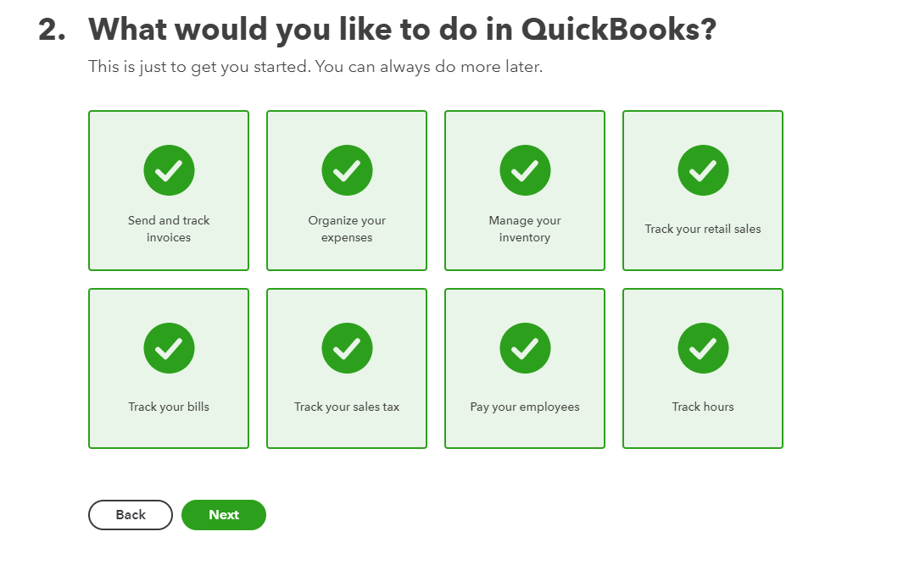
Then click Next and choose owner as your role.
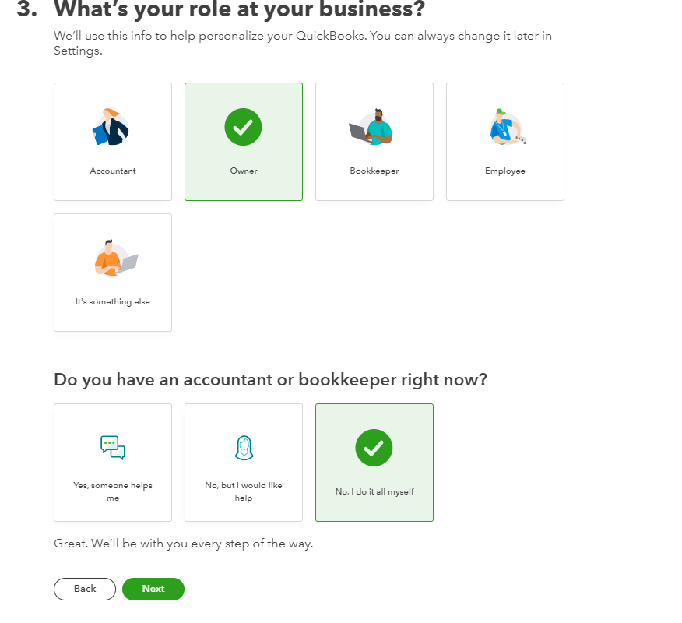

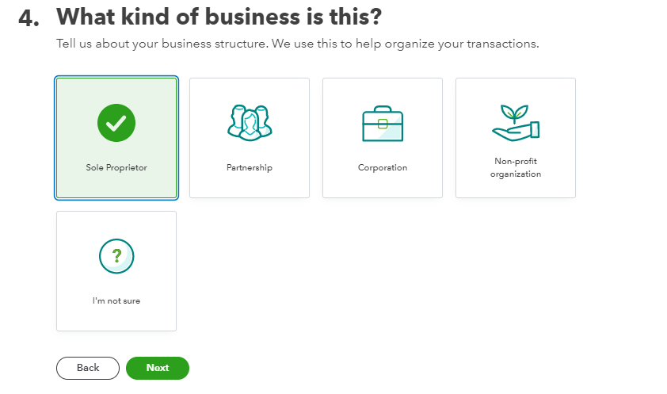
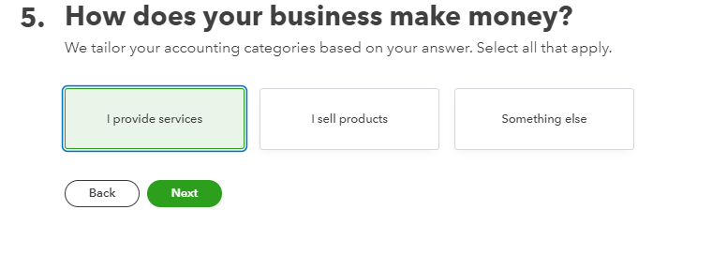
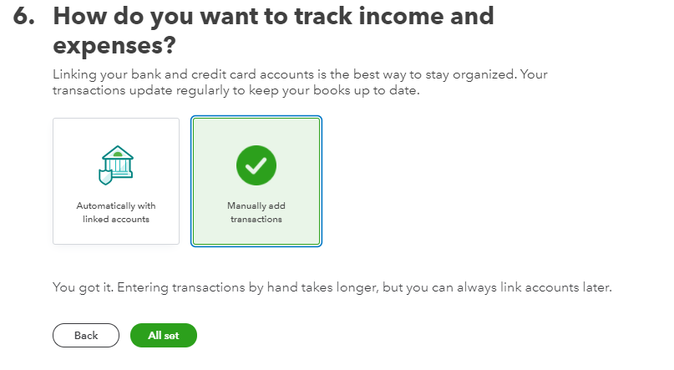
Page 628, please use the following industry.
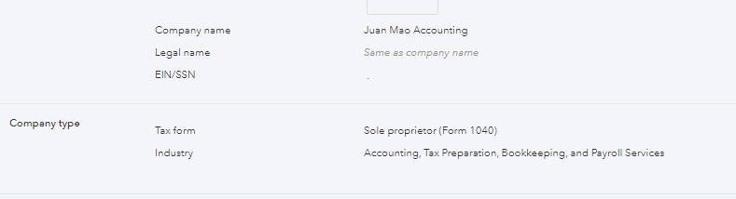

Page 629 Chart of Accounts and Beginning Balances

If it does not say in the Name column (Edit the default account), please add the account.

To add accounts, please follow page 74-81 for instructions.
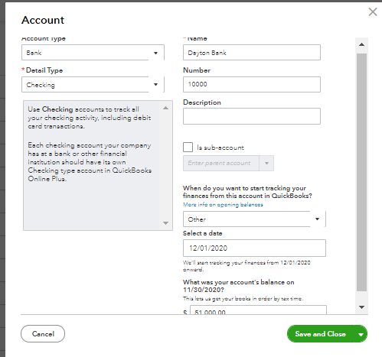

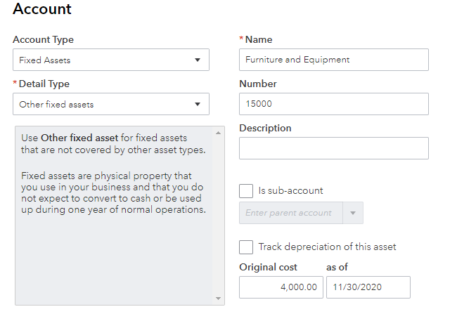
Page 635

Check No. | Date | Vendor | Description | Account/Category
 | 12/1 | Clients | Deposit | 41000
9001 |  | Our Bank |  | 25000; 63400, please see the following screenshot
9002 |  | Main Office |  | 14500
 | 12/16 | Clients | Deposit | 41000
9003 |  | North Tephone |  | 68100
9004 |  | U.S. Post Office |  | 66500
9005 |  | Accounting Online Journal |  | 62500
9006 |  | Jeanne’s Repair |  | 67200
 | 12/22 | Clients | Deposit | 42700
9007 |  | Cays Advertising |  | 60000
 | 12/24 | Clients | Deposit | 41000
9008 |  | Town Utilities
 | 12/24 | Clients | Deposit | 42700
9009 |  | Admin Asst |  | 61550;  Note: Add the Payee Admin Asst and Choose the type Employee
9010 |  | Acctg Tech |  | 61600
9011 |  | Owner’s Draw |  | 30800
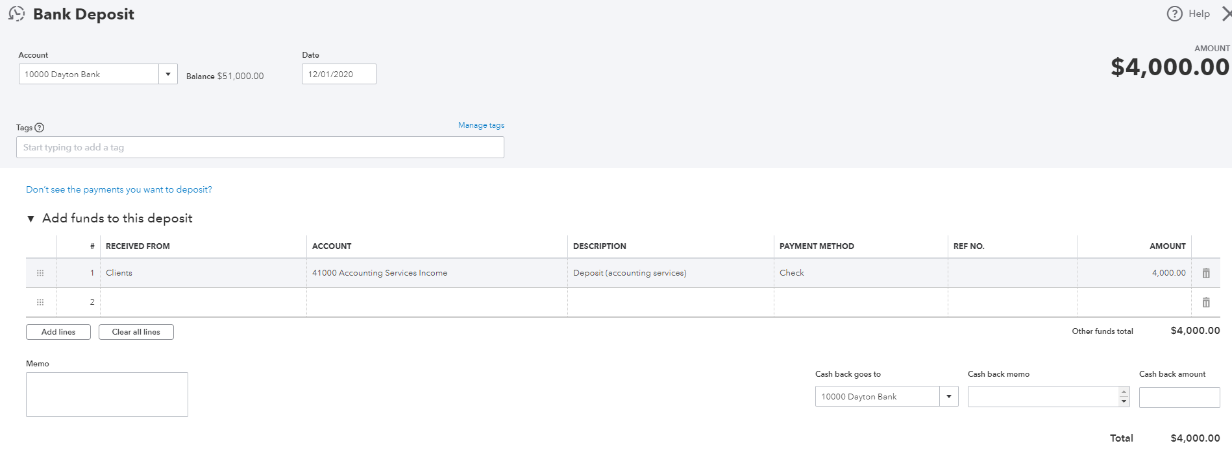

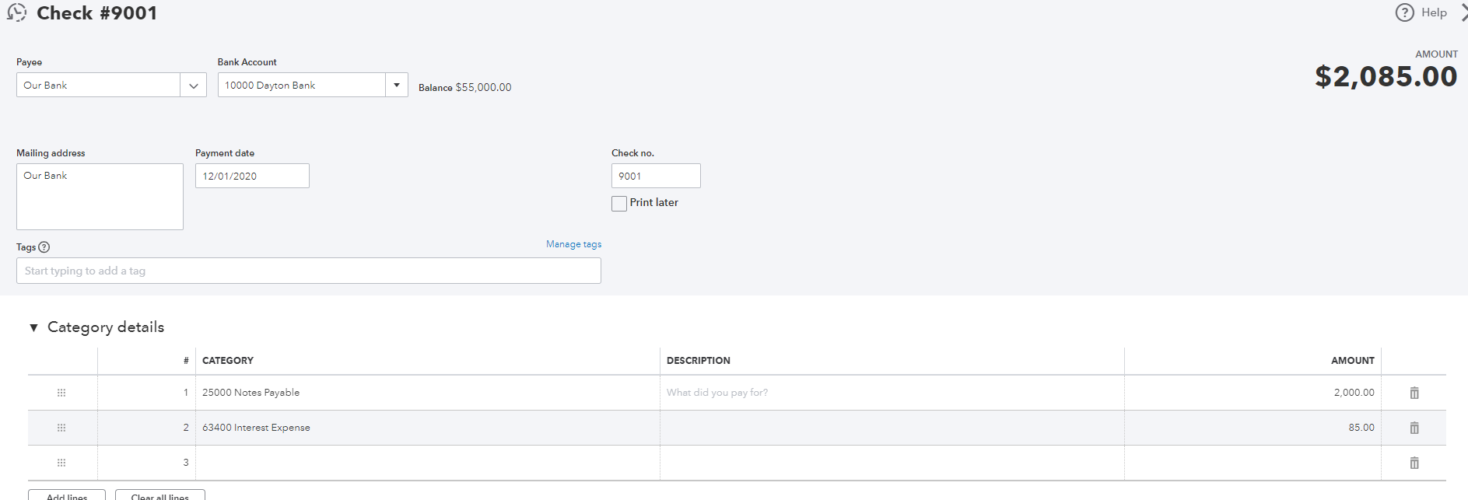

Pages 636 Adjusting entries (please refer to page 332 for instructions if you do not remember how to do);
For the 1st supplies adjustments, the amount of supplies expense equals the balance of supplies in the unadjusted trial balance minus the supplies on hand. This knowledge also comes from your Principle of Accounting I.
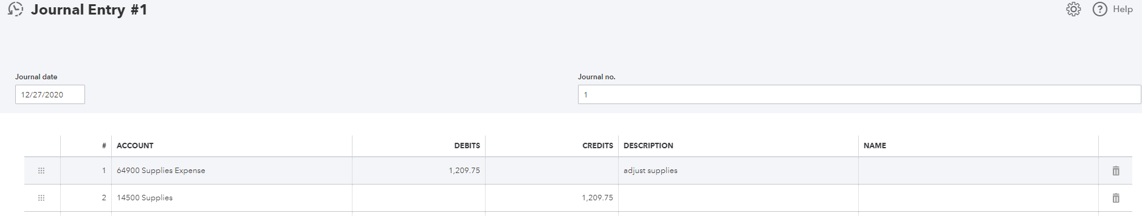

Page 637
Please note that Bank Service Charge is 18.

